**Testing JAVA Applications and Writing Test Cases**

---------------------------------------------------------------------------------------------------------------------------

After completing this handson you will be able to **write Test cases** irrespective of any **testing framework**

For eg: consider three screens.

* A login screen
* An employee display screen, which lists all employees in the organization
* An employee modification/addition/removal screen.

The UI (User Interface) for these three screens are developed with JSP/HTML and the validations performed through JavaScript. Because it is a sample application, logic is in the Servlet and DAO (Data Access Object). DAO is a class for connecting to the database.

**Below are the sample screens:**

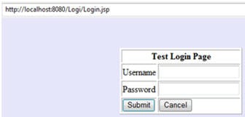

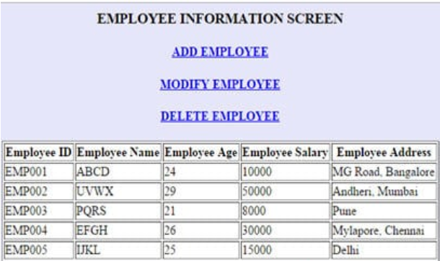

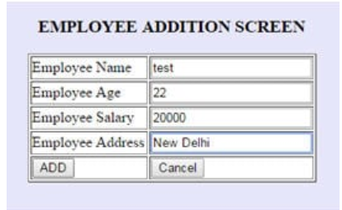

### **Manual Java Application Testing:**

During manual JAVA testing, a tester prepares the test cases from the detailed design document and tries to cover every scenario and code snippet possible.

**JAVA UNIT TESTING**

[Unit testing is a type of testing](https://www.softwaretestinghelp.com/unit-testing/) wherein a user needs to test the smallest of the code snippets for accuracy, correctness and meeting the requirements

Let us take the example of the login screen. The login screen has two text fields: username and password, and has two buttons: submit and cancel.

The test cases should cover all the loops and conditional statements. Test cases should display the expected results and the test data. Below are some of the general test cases that a user could execute manually in a login screen. The results are then noted down in the test case document.

**Below is a sample test case format for the login screen.**

**NOTE: All the test cases related to 3 screens are combinedly written in one table**

| **S.No.** | **Test Case** | **Expected Result** | **Actual Result** | **Pass/Fail** |
| --- | --- | --- | --- | --- |
| 1 | User checks the appearance of labels Username, Password | The labels should be correctly spelled and displayed in Normal sized font | The label username and password are displayed correctly | PASS |
| 2 | User checks the appearance of the button Submit and Cancel | The buttons should be displayed with the correct name | The buttons Submit and Cancel are displayed correctly | PASS |
| 3 | User checks the background color of the screen | The login form should be within a white table and the screen should be of background grey | The screen appearance does not match the requirements. | FAIL |
| 4 | The user leaves username textbox as Blank | Error message “Username cannot be empty” should be displayed | Error message “Username cannot be empty” is displayed | PASS |
| 5 | The user enters some value in the username textbox and leave the password textbox as Blank | Error message “Password cannot be empty” should be displayed | Error message “Password cannot be empty” is displayed | PASS |
| 6 | User enters username as “abcd” and password as “xxxx” | Error message “Invalid username password combination” should be displayed | Error message “Invalid username password combination” is displayed | PASS |
| 7 | User enters a username of more than 10 characters | Error message  “Username should not be more than 10 characters” should be displayed | Error message is not displayed | FAIL |
| 8 | User enters username as “testuser” and password as “password” and clicks the Submit button | The user should be able to see the “Employee details screen” | Employee details screen is displayed | PASS |
| 9 | User enters username as “testuser” and password as “PASSWORD” and clicks the submit button | Error message  “Invalid password, Password is case sensitive” | Error message  “Invalid password, Password is case sensitive” is displayed | PASS |
| 10 | User enters username as “test@user” and passwords as “password” and clicks the submit button | Error message  “Special characters are not allowed in username” | Error message  “Special characters are not allowed in username” is displayed | PASS |
| 11 | User enters username as “testuser1” and passwords as “password” and clicks the submit button | Error message  “Numbers are not allowed in username” | Error message  “Numbers are not allowed in username” is displayed | PASS |
| 12 | User enters his password, check if the password (text) is visible or not | Password is hidden and ************ is shown instead of actual text | Password is hidden and ************ is shown instead of actual text | PASS |
| 13 | Delete a username/password combination from the database and check if the combination is not able to login again | User should not be able to login, “Invalid username/ password” | User is not able to login and error message is displayed | PASS |
| 14 | If user is using the application first time, check if the username has permission to enter the application | User should not be able to enter the application until he logins with valid credentials and error message is displayed saying “Unauthorised access” | User is not able to login and error message is displayed saying “Unauthorised access” | PASS |
| 15 | Check if the Submit and Cancel button work as per requirement | On successful login Submit should redirect inside app and if unsuccessful login is there it should show error page. Cancel should terminate the current process | Submit and Cancel button works properly | PASS |
| 16 | Check if the user logged in and session are the same in all the other new integrated screens | It should maintain the session in all the integrated screens | It should maintain the session in all the integrated screens | PASS |
| 17 | Check that when clicking on Submit buttons, the control is transferred to the next screen | Control should transfer to the next screen | Control transfers to the next screen | PASS |
| 18 | Check that when clicking on the Cancel button, the action performed is cancelled | The action performed should get cancelled when clicked on Cancel button | The action performed is cancelled when clicked on Cancel button | PASS |
| 19 | Check if any field is left unfilled i.e. null | An error message should be displayed saying “Fields should not be left empty” | Error message displayed | PASS |
| 20 | Check that new data is being added to the display list when ADD button gets clicked | Display list must get updated when new data is passed and ADD button is clicked | Display list gets updated when new data is passed and ADD button is clicked | PASS |
| 21 | Check that ADD button does not accept any null data field, if user keeps any of the field null , ADD button should return error message and not direct to next page | ADD button should show error message on leaving any field null otherwise accepts the data. | ADD button shows error message on leaving any field null otherwise accepts the data. | PASS |
| 22 | Check if user enters Employee Age less than 21 | Employee Age field should not accept age less than 21, if entered so it should show error page | Employee Age field does not accept age less than 21, if entered so it shows error page | PASS |
| 23 | Check if user enters any number or special characters in Employee Name | Employee Name field should not accept any number or special characters | Employee Name field does not accept any number or special characters | PASS |
| 24 | Check if DELETE EMPLOYEE option works properly | DELETE EMPLOYEE option should delete the selected employee details | DELETE EMPLOYEE option deletes the selected employee details | PASS |
| 25 | Check if MODIFY EMPLOYEE option works properly | MODIFY EMPLOYEE option should enable the selected row to be updated and should display the updated row set in display list | MODIFY EMPLOYEE option enables the selected row to be updated and displays the updated row set in display list | PASS |

After going through the test cases, you may realize that you are mostly dealing with the testing of fields, buttons, functionality, and validations of a particular screen. This is accurate, as Unit Testing very keenly deals with the testing of every small code snippet and component. The same type of testing should be performed for all the screens.